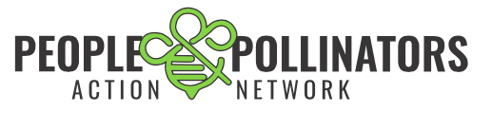

PPAN Pollinator Safe Pledge

The goal of the People and Pollinators Action Network (PPAN) is to create safe zones for bees, pollinators, pets and people, one garden or landscape at a time. Please go to [www.peopleandpollinators.org](http://www.peopleandpollinators.org) for more information.

How you can help

1. Eliminate the use of synthetic pesticides and fertilizers on your property.
2. When purchasing plants or seeds, ask nursery or garden center staff if the plants were treated with pesticides.
3. Encourage your city or park district to use alternatives to pesticides whenever possible.
4. Create patches of pesticide-free, pollinator-friendly flowers in your garden or neighborhood. For lists of suitable plants, visit www.xerces.org.
5. Share this information with your neighbors and local community!
6. Show your commitment to providing safe pollinator habitat by signing the Pollinator Safe Pledge!

Pollinator Safe Property Pledge

*As pollinators and people are endangered by the use of pesticides and other harmful chemicals in the environment, and there is a critical lack of safe healthy food for pollinators to eat and I am aware of these dangers, I pledge to help reduce the amount of pesticides in the environment and to increase the amount of pollinator safe habitat.*

*I am committed to maintaining a pollinator friendly property. I do not use pesticides and I do my best to plant pollinator safe plants.*

Sign the Pollinator Pledge online at <http://peopleandpollinators.org/our-solution/psn-pledge/>

---------------------------------------------------------------------------------------------------------------------------------------------Name: ________________________________________________________

Address: ______________________________________________________

Email: ________________________________________________________

Can we show your pledge on a public map? **Yes No**

Would you like to receive action alerts? **Yes No**

Would you like to volunteer with PPAN? **Yes No**